**Steps#7-**. the report Published on Power BI cloud service

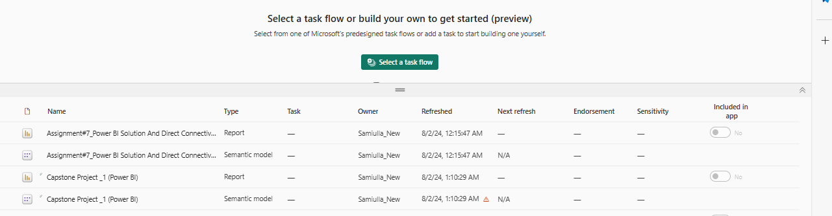

and created master dashboard

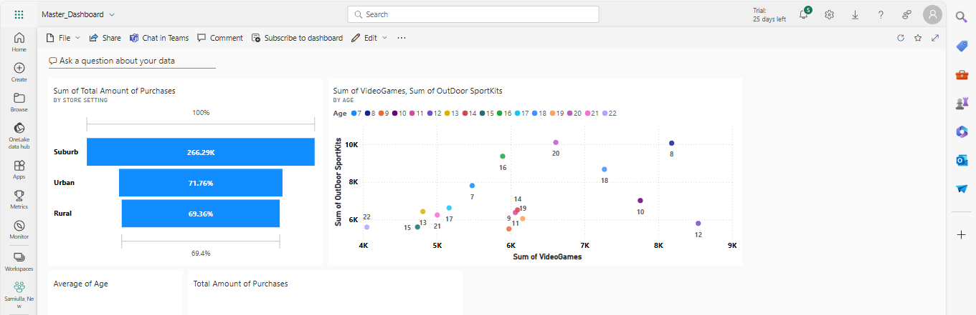

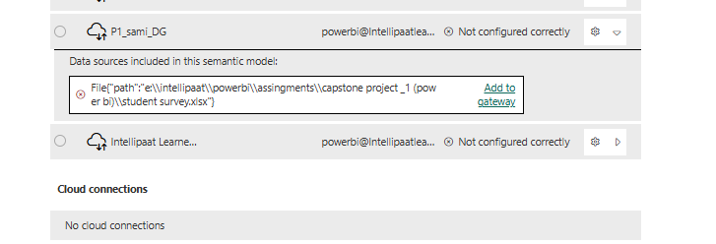

File Path Connection Created and file path linked to Gateway Connection 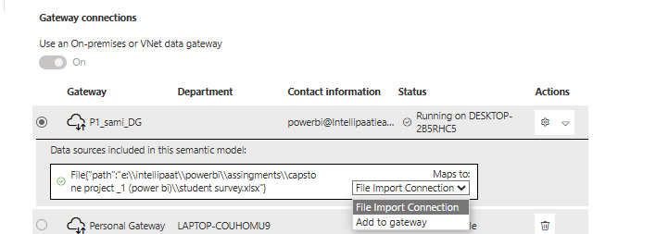

Configured a refresh schedule 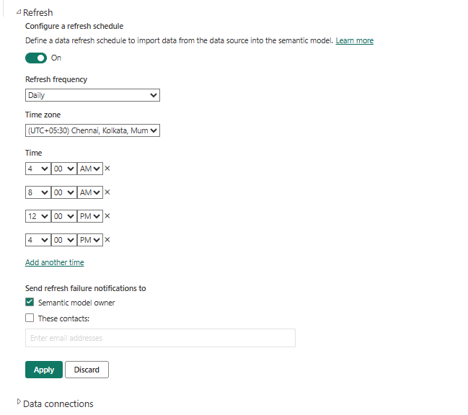

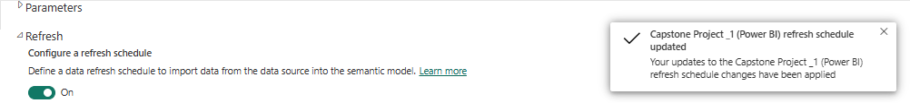

Successfully updated Scheduled Data Refresh.

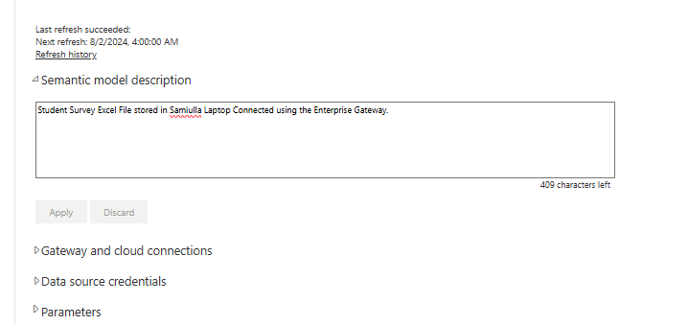

**Steps#8-**. **Use Q&A feature of Power BI** –

a) average age of students

b) total amount of purchases by ‘Store location’ as Donut chart

